

**KHULNA UNIVERSITY OF ENGINEERING & TECHNOLOGY**

Department of Computer Science and Engineering(CSE)

**PROJECT ON CSE3110**

**Course Title:** Database Systems

**Project Name : Phone Book’ Database**

***Submitted To:***

**1. Md. Masum Al Mesba**

Assistant Professor

Department of Computer Science and Engineering (CSE)

Khulna University of Engineering & Technology(KUET)

**2. Nazia Jahan Khan Chowdhury**

Assistant Professor

Department of Computer Science and Engineering (CSE)

Khulna University of Engineering & Technology (KUET)

***Submitted by:***

MD. Mehedi hasan Emon

**Roll:**1807072

**Year**: 3rd Semester: 1st

**Submission Date**: July 21,2022

**Project Overview**

All the information of a phone book needed can be managed in this project. Information about customers, sim number, sim operator name, user package details, call record details, call cost of certain duration all of these can be managed in this project. Here we can able to see the sim number the user have and the call record of that particular user and the packages he uses. Here a user can also see this expenses.

**Database Structure**

The database consists of seven tables and they are customer details table, sim table, package table, call cost table, operators table, call record table, user package table.

Customer details table have one to many relationship with sim table. Operators table have one to many relationship with sim table. Operators table have one to one relationship with call cost table. Again operators have one to many relationship with call record table. Then sim have one to many relationship with call record table. And last package have many to many relationship with sim table.

**ER Diagram:**

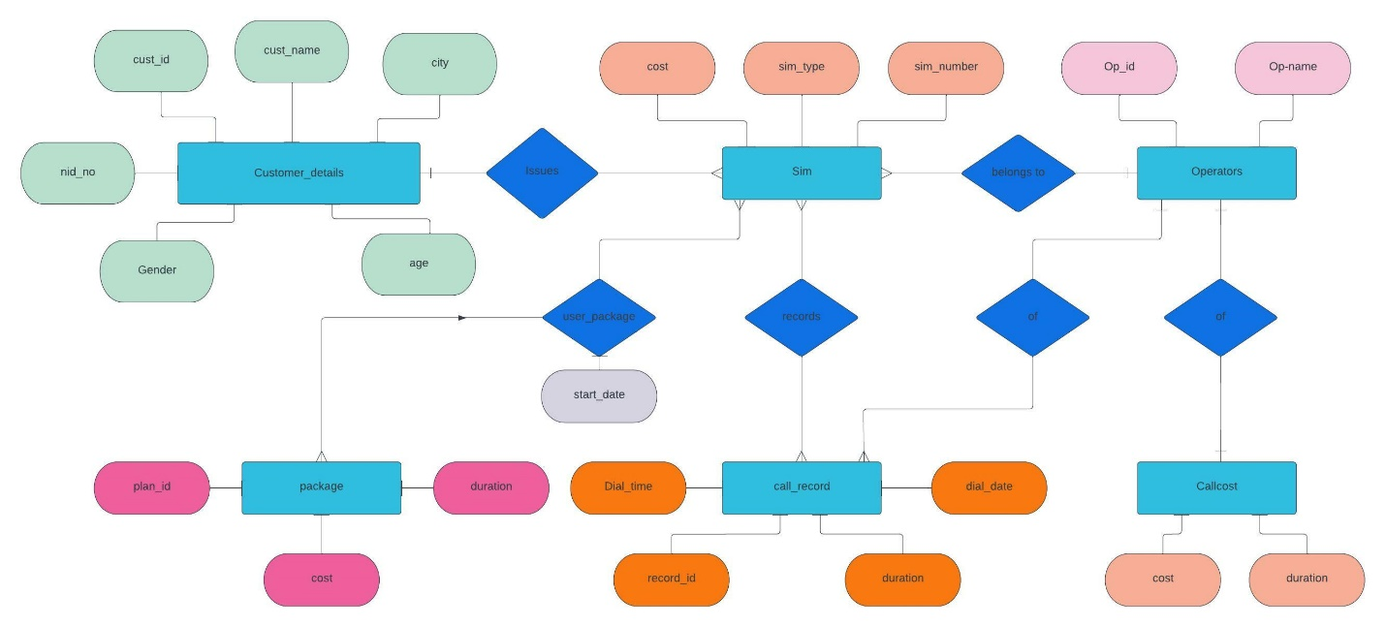

**Schema Diagram:**

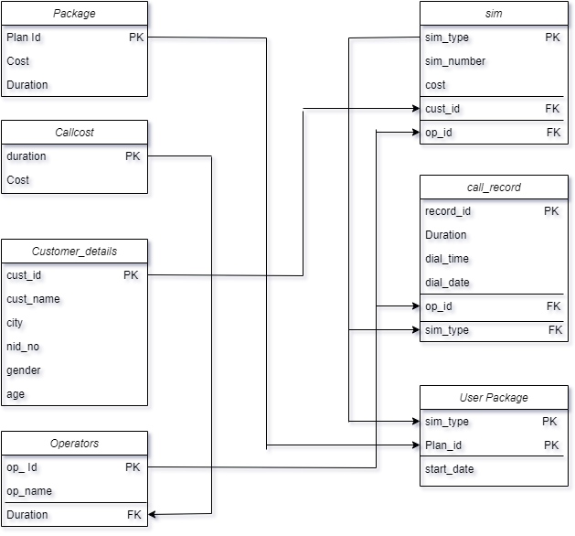

**Functionality**

Some main functionality of this database project are given bellow.

1. Here one PL/SQL block that when a user buy a sim if it matches with certain sim company and the sim cost in some range then he will get some discount. And the discount amount will depend on the cost amount.

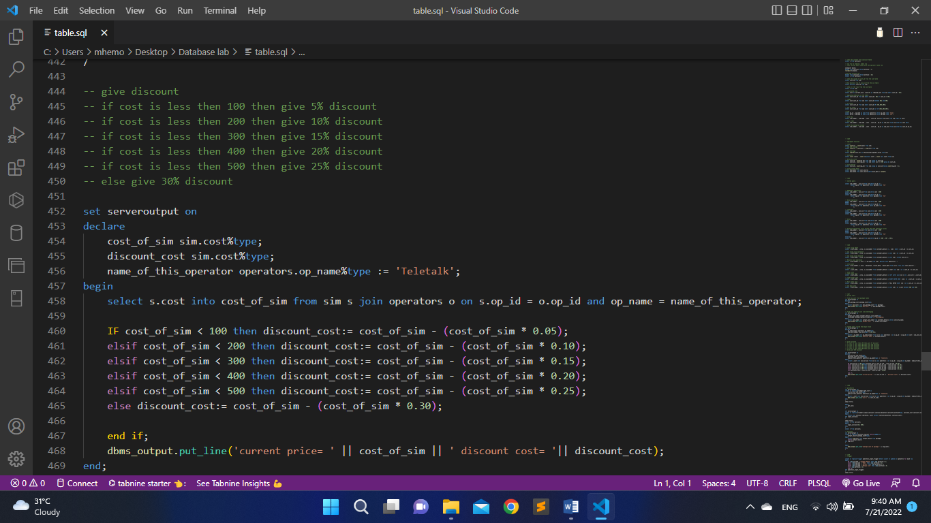

1. By this procedure a user can input data into a certain table:

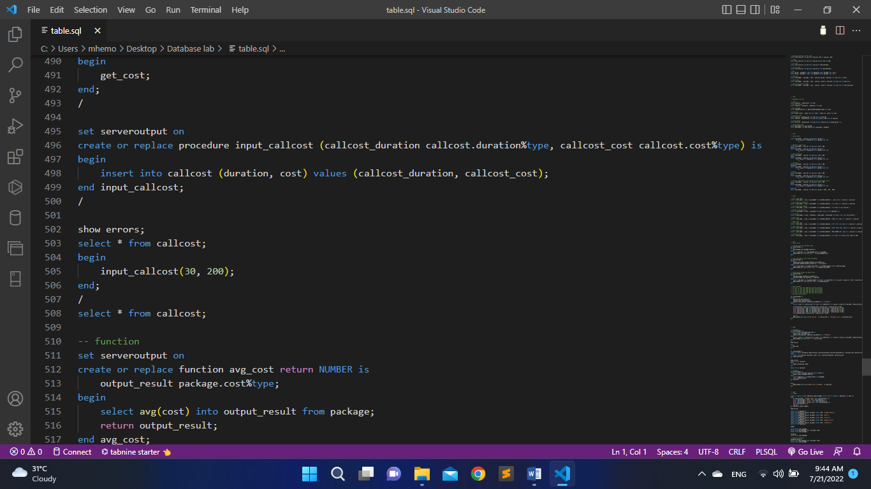

1. Here is one Trigger it will automatically called when we insert data into the table.

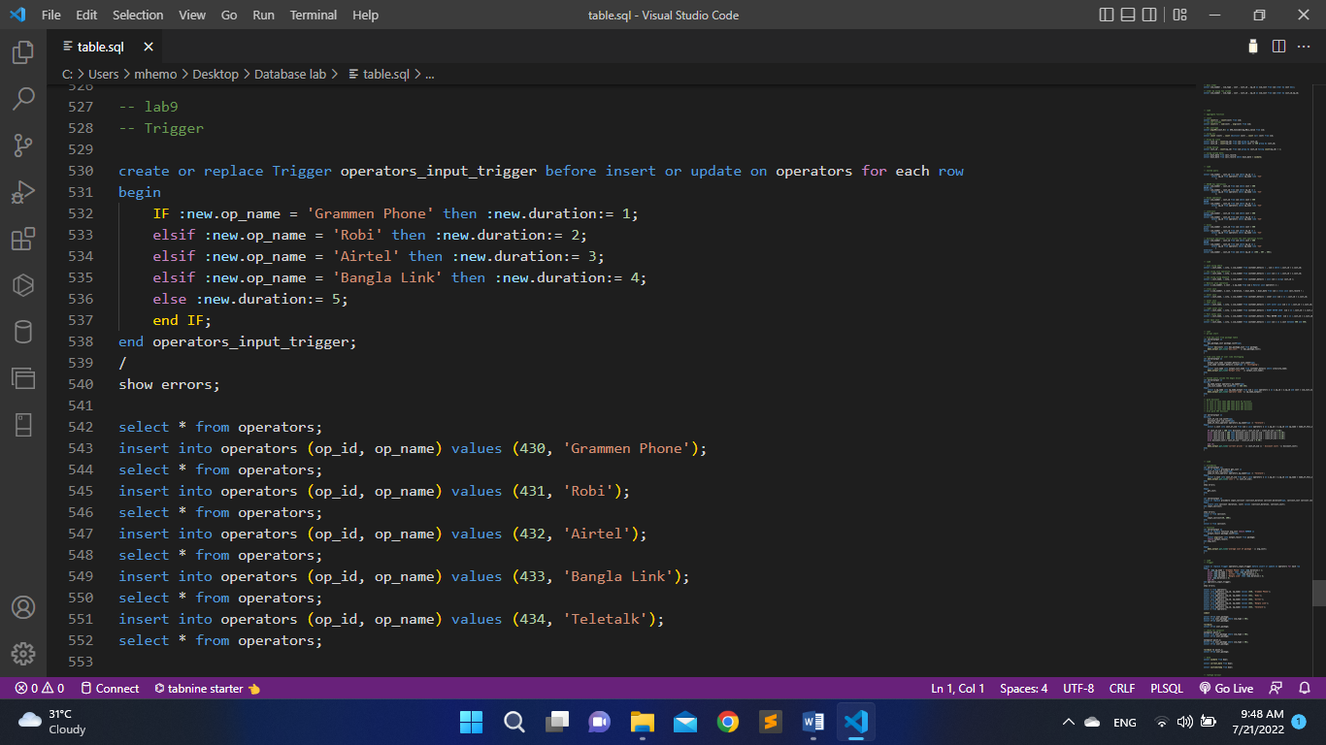

1. Here a PL/SQL block that will return call record operators name , call record duration and it will sort it by system current date.

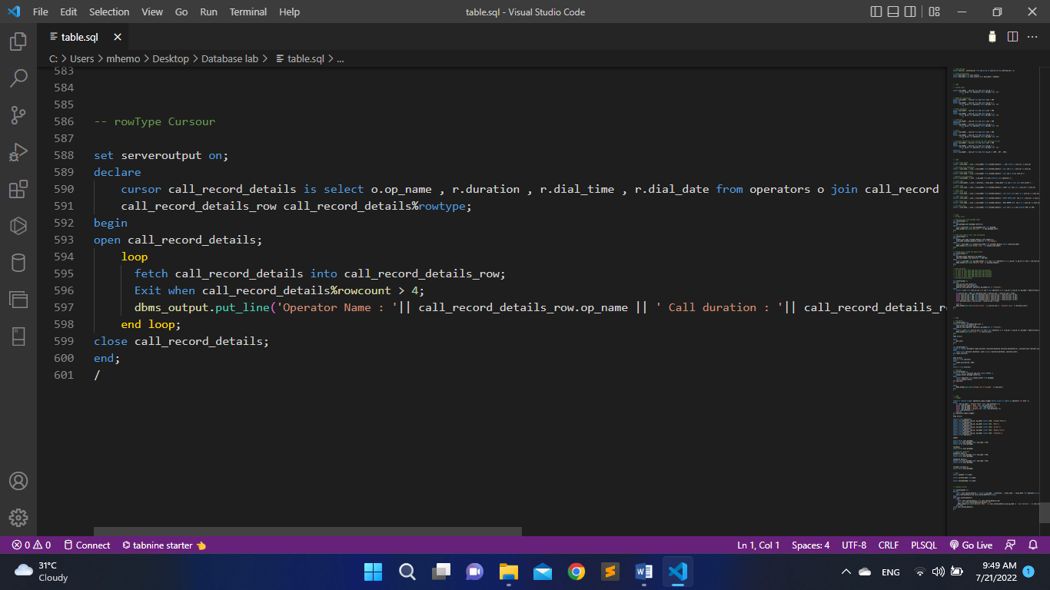

**Database Design Process**

This database project is developed by ORACLE . We developed seven new tables and inserted data from file.

We learned several important lessons through the design process. These include:

1. Designing tables is the most important step and must be done early in the project.

2) Building a database and web application from scratch is often easier than revising anexisting database and application – which is why initial design is so important and wasstressed throughout the course!

**Discussion & Conclusion**

The project was a learning experience for us and allowed us to improve upon our SQL skills. From this we learn about database management system, sql query, function procedure, trigger, cursor etc that help us for future database development .We developed a database system for managing phone book.

**Reference**

[**https://www.w3schools.com/sql/**](https://www.w3schools.com/sql/)